**Azure**What is Cloud 🡪 central location to store data (store huge volume of data in a location and access it from anywhere in the world)  
Cloud Computing 🡪 provides on demand computing resources (Pay as you go 🡪 pay for the services we are using)  
Cloud has Data Centres (have remote servers and based on the Endpoint provided by Cloud we access the resources, highly secure)  
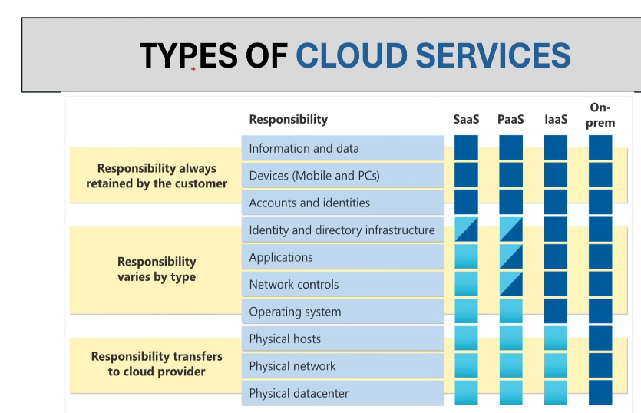  
On-premises : self-owned  
IaaS : Infrastructure as a service 🡪 Azure will simply provide the infrastructure eg. Virtual Machines, so once the VMs are ready Azure will not be responsible for any kind of upgrades or maintenance  
PaaS: Platform as a Service 🡪 requesting for platform/application eg. Az SQL db (Managed by both Azure and us); we can configure the networking  
SaaS: Software as a Service 🡪 We only have to manage data, devices rest all by cloud eg. Fabric  
  
**Fault Tolerance**  
Azure replicates data to multiple Data Centers 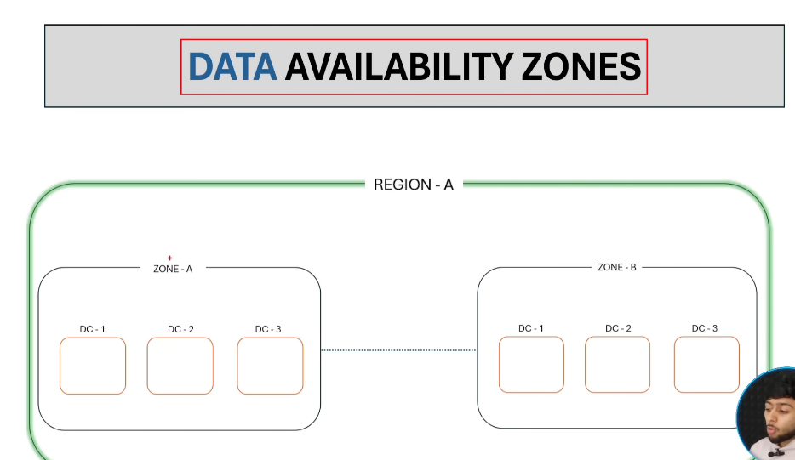  
If one zone is effected, then another zone will be active  
If entire region gets affected  
That’s the reason Azure gives 99.99% data availability  
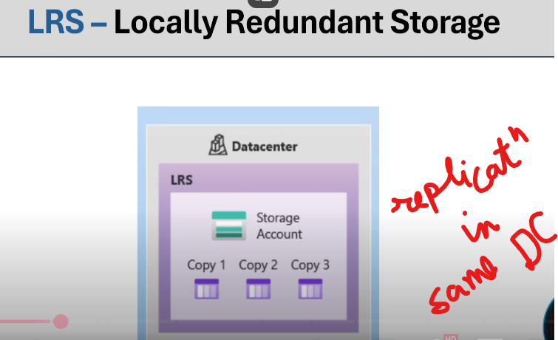 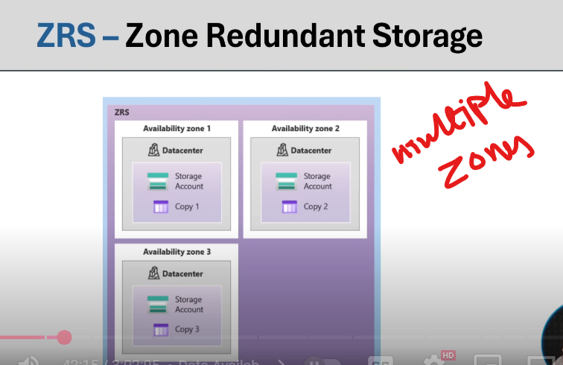  
  
Now lets create Azure SQL database (for Structured data)  
Search with Azure SQL 🡪 SQL databases  
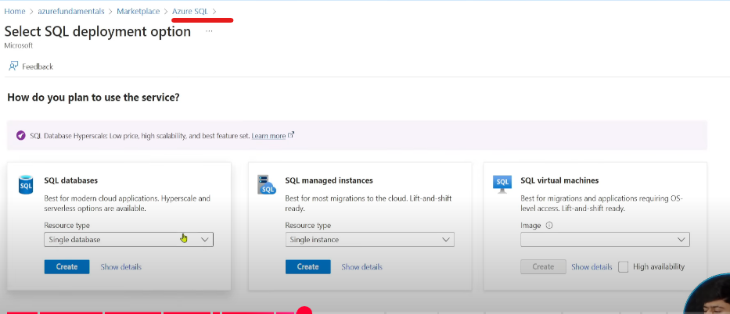  
SQL managed instances: PaaS, SQL VM: IaaS 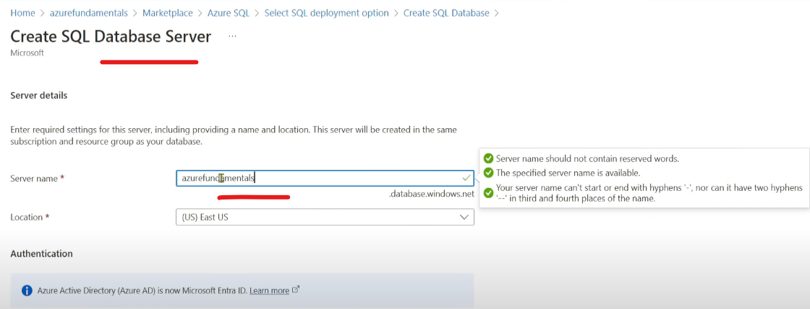 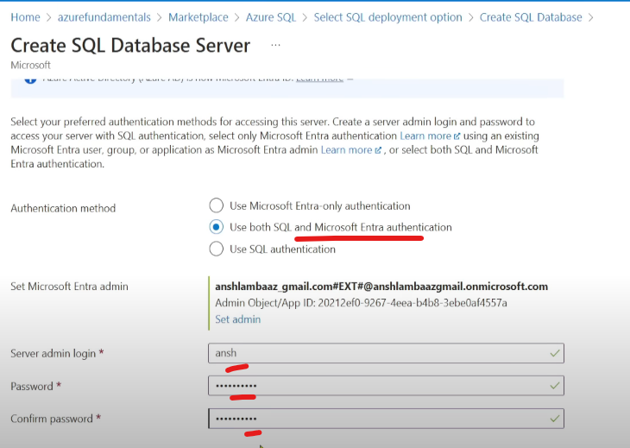  
  
Now lets create Azure Cosmos db (for SemiStructured data/No SQL db🡪 Non Relational data)  
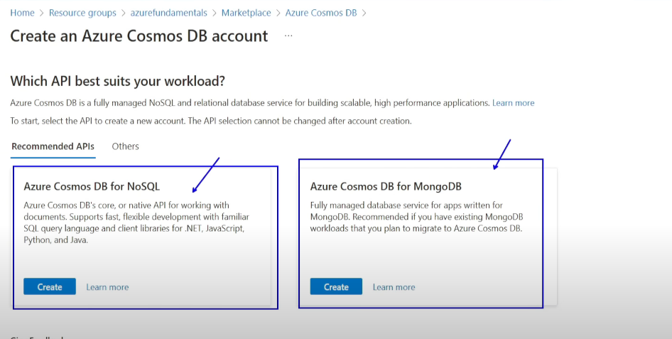   
Azure Cosmos DB for NoSQL (previously Azure Core SQL) 🡪 mostly data in key value pair  
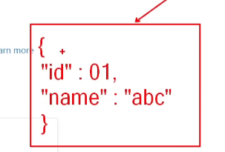& we can use select query to operate on this data  
  
Azure Cosmos DB for MongoDB : special type of Azure Cosmos DB for NoSQL  
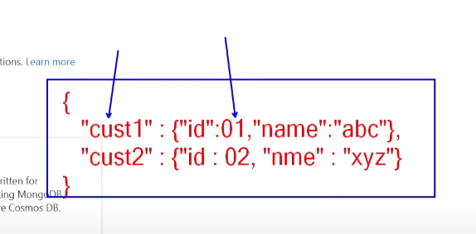Value is form of JSON  
  
Azure Cosmos DB for Apache Gremlin : Graph databases (relation between nodes)  
Azure Cosmos DB for Apache Cassandra: Hierarchy of columns within our data 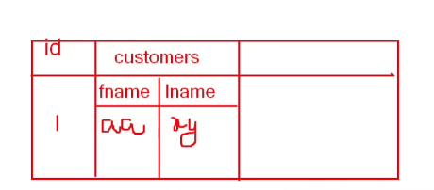family of columns

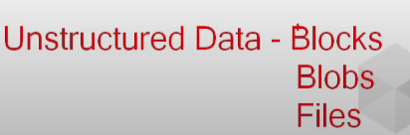  
Blocks: when we store data in hard drive, it gets saved in form of Blocks, in Azure its get saved in Disks  
Blobs: Data Lake is built on top of Blob Storage  
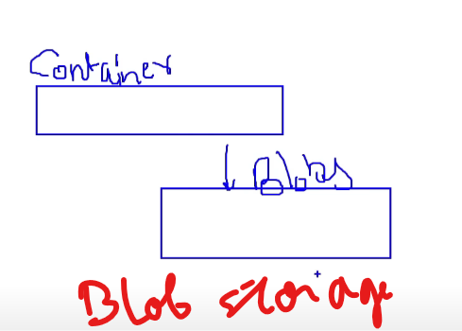  
It takes some time to get the data from Cold and read it from there.  
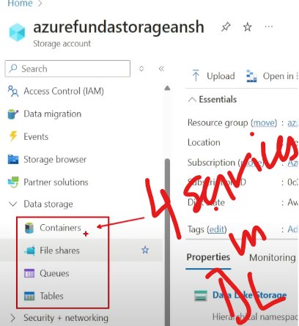  
Containers : Data Lake  
File Shares: lets say our org has 10-15 VMs, manager will push the files in central repository, to access the file for anyone in the team.  
Queues: messaging service/real time data from IOT/sensors, data will come in Queues in form of packets in FIFO   
Tables: semi structured data(key value data)

Lets create a Table  
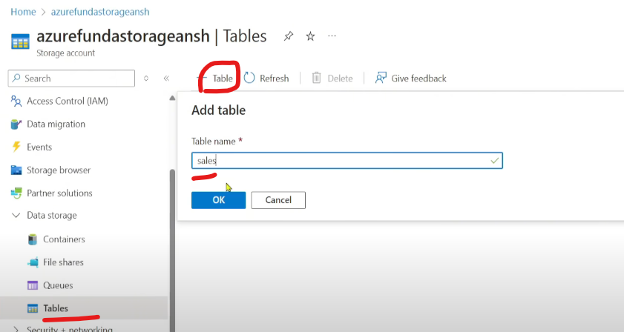  
But we cant do anything over here, we have to go to Storage Browser 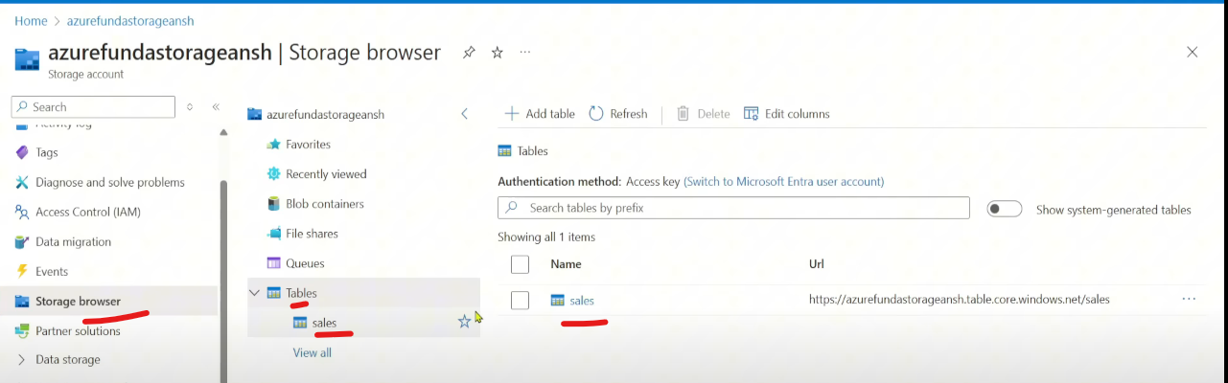  
Rowkey : primary key for each partitions , combination of both PartitionKey and RowKey are treated as Composite Primary Key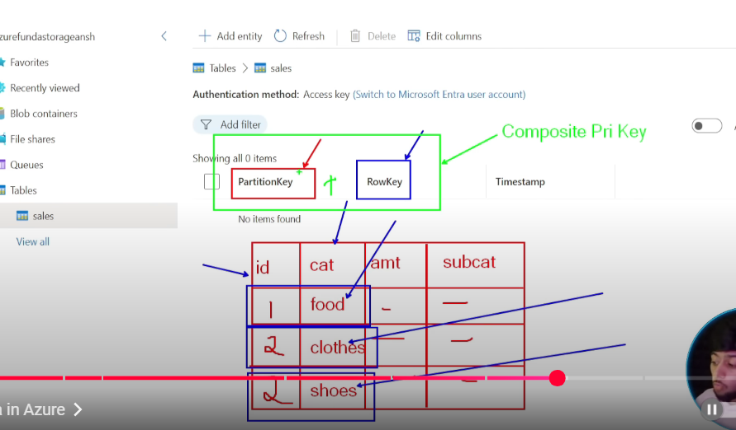

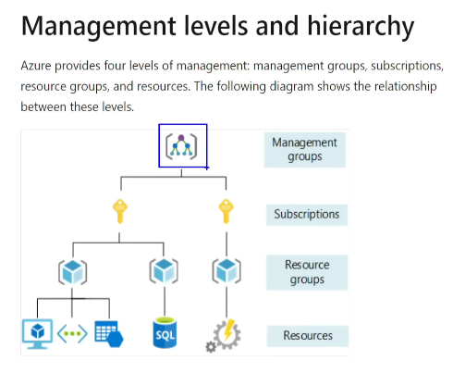  
Management Groups/Tenants: Owner of the platform/Domain  
Subscriptions: Purpose 🡪 To have different bills for different departments of the company  
RG: folder to hold those resources  
  
Entra ID: kind of Admin portal where we can manage users/MI/SPN  
  
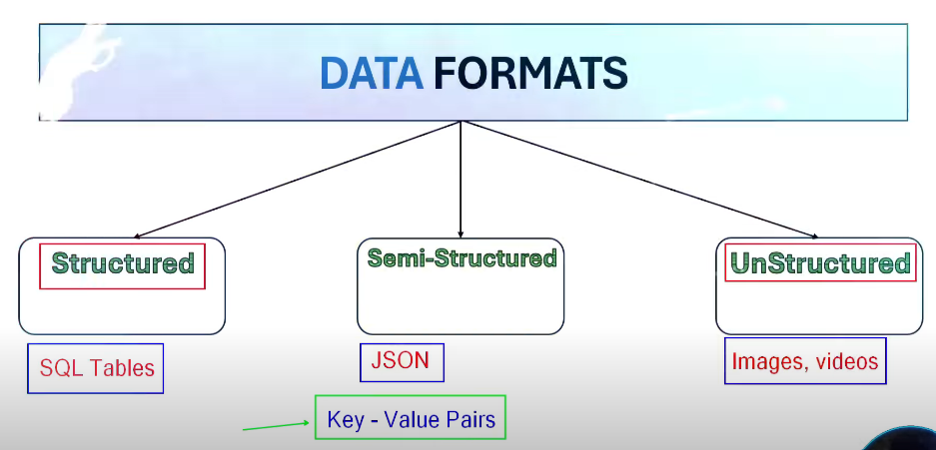   
Structured: columns/rows, proper schema or structure  
Semi-Structured: structure which is not fixed  
UnStructured: mostly using in AI  
  
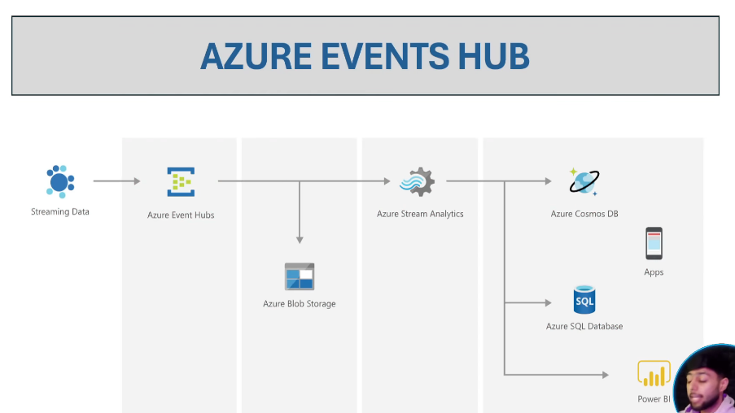  
Event Hubs ingest data in real time manner and also provides us a temporary solution to store the data (for few days), these data will be consumed by Stream Analytics & Blob Storage.  
Event Hubs are alternative to Apache Kafka, EV holds data in form of Events whereas AK holds data in form of Messages.  
Stream Analytics 🡪 processing tool for data transformation  
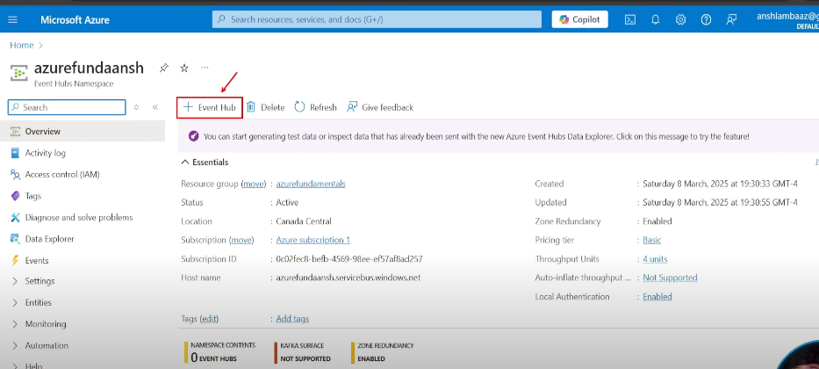  
Retention time : time the data will stay in EH  
Send Events : provide a Streaming source and create a data to get ingested  
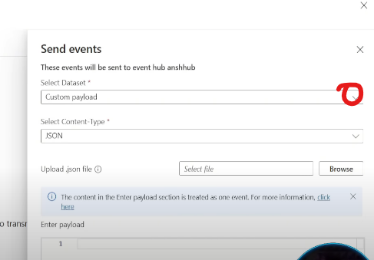  
Choose a sample template  
